Click the icon below to view tournament results

Be sure to view the results of the Albuquerque Regional by clicking the icon below. El Pasoans accumulated 233.48 masterpoints!!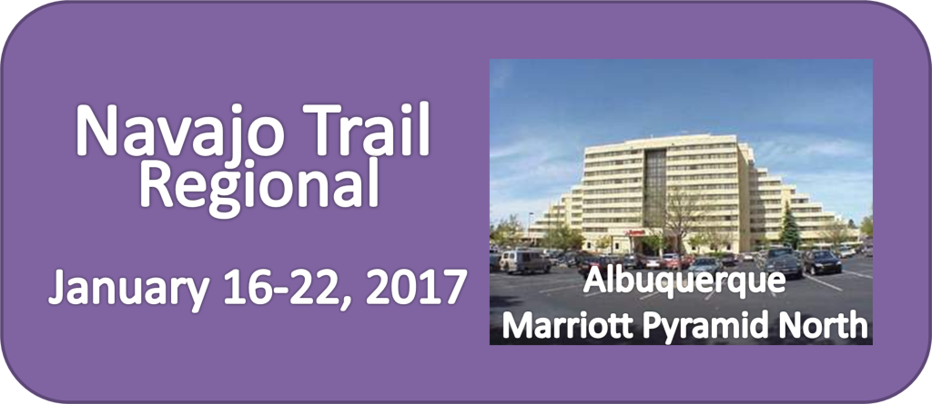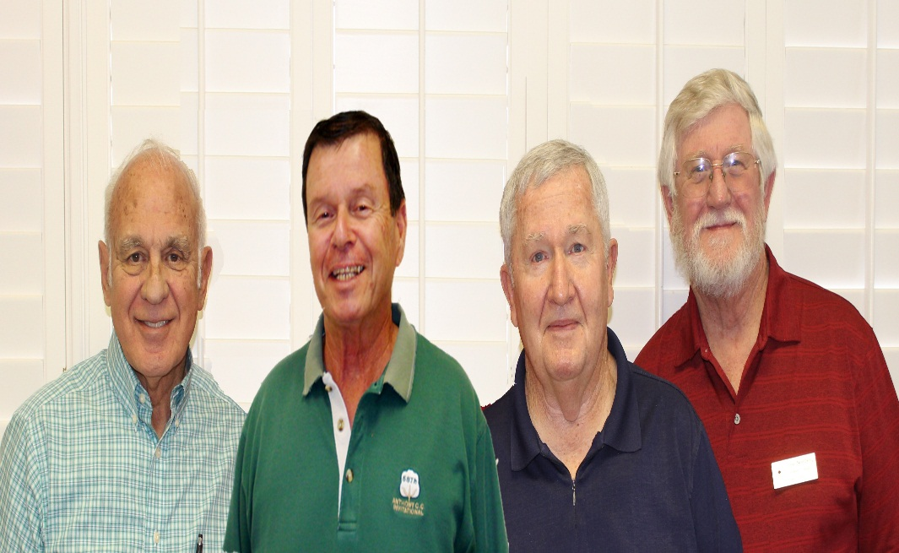

SUNDAY 0-3000 TEAMS-BKT 1 - 7 Tables

MPs | Rank | Names
10.08 | 1 | Ralph Liguori - Peter Peca Jr - Donald Klenke - Stephen Nordberg, El Paso TX

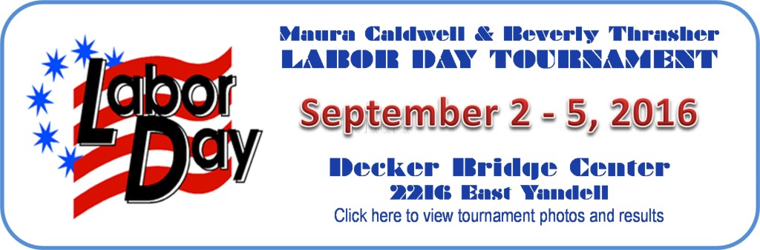

♠♥♣♦♠♥♣♦♠♥♣♦♠♥♣♦♠♥♣♦♠♥♣♦

Click icon above to see all the winners and points earned at the tournament!
♠♥♣♦♠♥♣♦♠♥♣♦♠♥♣♦♠♥♣♦♠♥♣♦

Click here to view 2015 Labor Day Tournament winners

♠♥♣♦♠♥♣♦♠♥♣♦♠♥♣♦♠♥♣♦♠♥♣♦♠♥♣♦♠♥♣♦

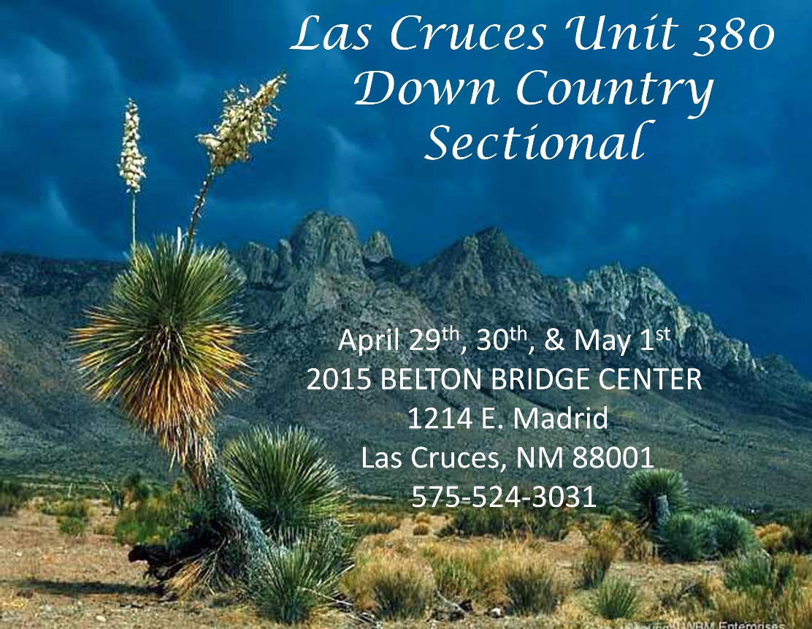

Click here to view photos of January 2015 Albuquerque tournament
♠♥♣♦♠♥♣♦♠♥♣♦♠♥♣♦♠♥♣♦♠♥♣♦♠♥♣♦♠♥♣♦

