Chuck Duke's wife, Maisie passed away in December 2015 (Obituary)
Lois Applebaum's husband, Richard M. Applebaum, M.D., 84, a resident of Las Cruces, New Mexico, formerly of El Paso, Texas, died peacefully at home on July 17, 2015. Here is their mailing address: 1751 Oro Piedras Drive, Las Cruces, NM 88011. (Dr. Applebaum's obituary)
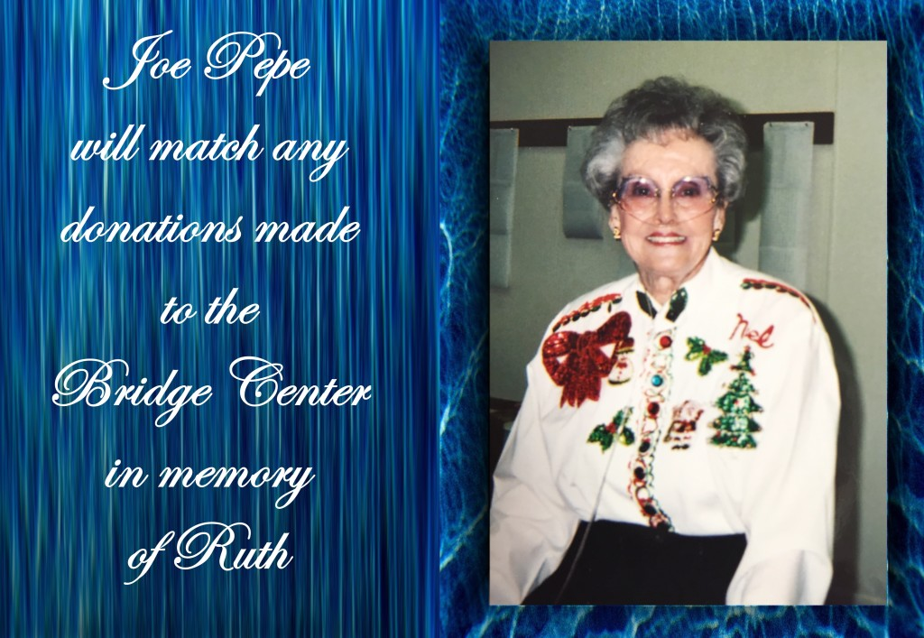
Very sad news, Ruth Pepe passed away peacefully in her sleep Tuesday evening, July 14, 2015. Ruth supported our bridge club in many capacities; chairing bridge tournaments, serving on Unit 159's Board of Directors as well as our representative on the District 17 Board of Directors. She has struggled with health problems for many years, but always made it back to the club to play bridge as soon as she was out of the hospital. She truly loved the game. She will be deeply missed and especially her beautiful smile. (Ruth's obituary)
Long time El Paso resident Frank Senkowsky died peacefully at 2:30 p.m. on May 21, 2015, under the care of Hospice. He was the son of Peter and Leona Senkowsky of Chester, Pennsylvania. After his honorable discharge after his service in the Air Force in World War II, he and his wife, Florence moved to Mexico City, Mexico where he was involved in the development of the manganese industry. He subsequently moved the business to El Paso in 1960, where he ran it successfully until his retirement in the 1980's. He was a parishioner at Queen of Peace Catholic Church and Past President of the Serra Club. He is survived by his wife Florence, son Jon and daughter-in-law Donna, grandchildren Molly, Emily, Frances and Grace. Services are with Martin West on Resler after cremation and the memorial Mass will be Thursday, May 28, 2015, at 10:00 AM, at Queen of Peace followed by a reception. The family would like to extend their appreciation for exceptional care provided by Dr. Jose Silva, Dr. David Dobrin and also the entire staff of Montevista at Coronado. Private interment. Services entrusted to Martin Funeral Home West.

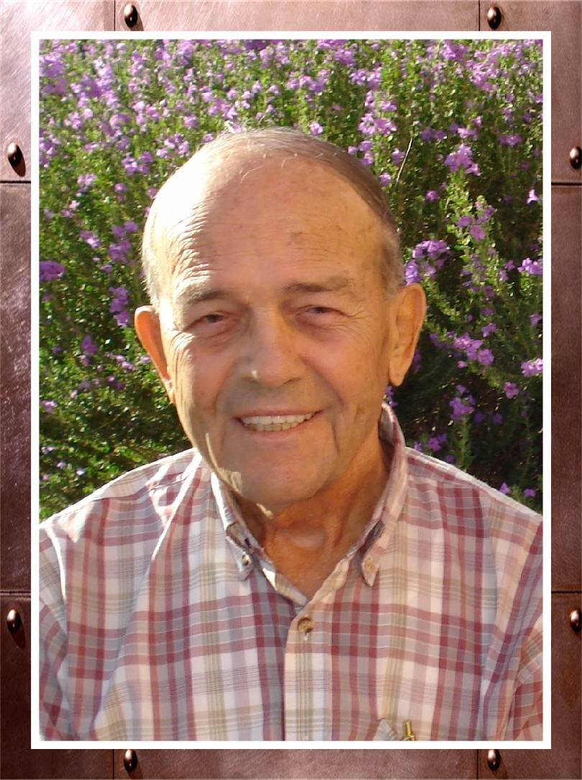

We have lost another bridge player and friend. Leonard Pacha passed away Sunday, April 26th. Leonard has been hospitalized for all but five days since January this year. Thank God he is no longer suffering and is in much better place. (Obituary)

Billie Mitchell's husband Leo passed away at age 89 on April 18, 2015. Billie has been a long time teammate of Gerald Georges and Bob Esch.

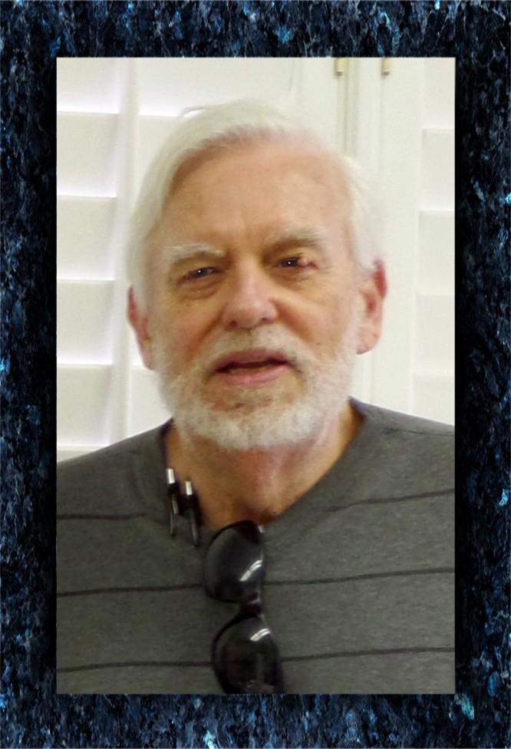

On the morning of March 10, 2015, Scott Campbell did not show up for his game with Barbara Harrid at the bridge center. Barbara went to Scott's apartment and found his car was there but he was not answering the door. The police went in and found that he had passed away. Scott will be dearly missed.

A lovely memorial service was held at noon on Sunday, March 15th, at the bridge center. Barbara Harrid officiated and many of Scott's bridge and race track friends, and his cousin told heart-warming stories remembering our friend. Thanks to Barbara and to Bob Esch's poetry readings.

Memories of friends from December 2013 to February 2015.

Included in the above link are: Garey Hayden, Bob Lyons, Lillian Silverman, Barbara Clark, Martin Kern, Babs Paschich, Lorraine Stewart, Betty Manross, Geneva King, John McLaughlin, Terry O'Donnell, John Bowden, and Addie Rider

